ME 423 Engineering Design VII

Phase 1 – Proposal and Conceptual Design

**3D Printed Granular Jamming Hand**

**A Senior Report**

**Group:**

Melissa Indoe

Chris Kang

Sean Phelan

Maggie Serra

Chris Wallace

**Advisors:**

Robert Chang

Jennifer Field

**STEVENS INSTITUTE OF TECHNOLOGY**

Castle Point on Hudson

Hoboken NJ 07030

(September 2013)

# Abstract:

An open-source and mainly 3-D printable hand prosthesis is to be developed by a team of five Mechanical Engineering seniors in a student-driven design project. The hand prosthesis will combine the technologies of existing 3-D printed hands with the concept of granular jamming to maintain a firm grip at a fraction of the cost of existing prostheses. The hand will allow for performance of relatively low strength, high dexterity, household tasks. To meet this goal, a background on types and incidences of amputation has been established, as well as on state-of-the-art designs in both professional and hobbyist prostheses. Potential users of the product have been identified, and some original research on hand usage has already been completed. Additionally, conceptual designs have been generated and compared, resulting in a generalized plan for future hand design, and a plan for future testing and development has been generated.

Table of Contents

Abstract: 2

Problem Statement: 4

Project Objective: 4

Social Impact: 4

Project Background: 5

State of the Art and Existing Designs: 5

Conceptual Designs: 9

Features and Comparisons of Conceptual Designs: 13

Technical Analysis and Engineering Design: 17

Deliverables for End of Semester: 19

Expected Budget: 20

Project Schedule: 21

# Problem Statement:

Thousands of arm amputations happen each year around the world. Loss of an arm can severely limit the independence of an amputee. There are current prosthetics that restore functionality to the missing limb of the amputee, but they are not available to many people globally due to cost and availability. There is a need to create an inexpensive and readily available prosthetic for amputees around the world.

# Project Objective:

The objective of this project is to create an open-source, affordable, and high-functioning prosthetic hand. The hand should be task-oriented and able to achieve household activities requiring relatively low strength and high dexterity. It should be similar in size and weight to a human hand, and look relatively similar as well, to make it appear relatable and human. The major issues involved in creating this mechanical hand are maintaining dexterity of the fingers, maintaining device durability, and holding low costs.

Primary task goals are as follows. Firstly, the hand should be able to pick up and put down objects of varying sizes and shapes. It should also be able to open and close doors of varying types, such as lever style doors, knob style doors, and refrigerator doors. To maintain some level of comparability (and avoid venturing too far into the uncanny valley), it should be able to perform simple gestures such as pointing, or giving a “thumbs-up” gesture. It should also be able to use a computer mouse. Computers have become an immensely important facet of society, and while a keyboard would prove too complex given the budget and timeframe, a mouse can certainly be used to perform most computer-based tasks (especially when paired with existing software meant to facilitate typing with the mouse). Finally, the hand should be able to use occupational therapy tools, such as cutlery and pencils or pens. Again, while it may prove too complex to use traditional utensils, the larger size of an occupational therapy device, combined with the abilities of the hand, should offer a level of autonomy that the user would not have had otherwise. If most or all of these task goals can be completed, the project will be considered a success.

Secondary goals are slightly more complex. Some examples of secondary goals are the ability to use touchscreens (via a conductive layer on the thumb and index finger), ability to open pop-top cans, achieving rotation, primitive myoelectric control (for opening/closing of the fingers), and allowing for joint locking so that certain positions can be held while only one joint is moved (useful for certain tasks, such as using a mouse or playing a note on a keyboard). If some or any of these goals can be achieved, it would add significant functionality to the project, however, these goals are not a priority, but are instead seen as a way to move the project forward if primary goals have already been achieved.

# Social Impact:

The design project has a very large societal impact. There are around 12,500 new arm amputations per year. Our project aims to create a lightweight, inexpensive, easily created robotic arm. The limb should be able to improve the quality-of-life for many of these amputees. If the cost is low enough, the prosthetic arm could be used in war torn countries like Afghanistan, Syria and Libya where many civilians are injured by IEDs or implanted mines. Also the limb can be used for our own soldiers returning from war or veterans that haven’t previously been able to afford the current prosthetic limbs. The prosthetic arm can also be used in many hazardous situations including the handling of hazardous materials, caring for babies in incubators, and in the manufacturing and automation industry. Our design is going to be made on an open source program where anyone can download, edit, or improve the project for free.

# Project Background:

About 12,500 new arm amputations happen every year. The types of arm amputations vary, but hand and lower arm amputations are a common place occurrence. In order to help amputees, mechanical hands and arms were developed, and have existed for years. These hands are often operated by cables attached to the shoulder and control grasp by shrugging. Unfortunately these devices make inaccurate motions, do not grasp irregularly shaped objects well, are uncomfortable, and expensive. Other types of prosthetic hands controlled by myoelectric sensors have existed for the last 5-10 years. These prosthetics are very expensive and heavy.

This project is designed to overcome limitations from these commercially available prostheses. This project is designed to be 3-D printed to lower both cost and weight. Additionally, the device will be made available for public use as open source, so anyone with access to a 3-D printer can print out his own device.

# State of the Art and Existing Designs:

In this section we will discuss a state of the art design manufactured by a medical technology company as well as designs made by laypeople. Medical device companies have the resources to design prosthetics that can be used for human use. Our focus will be on simpler models not meant as prosthetics that are easy to make and affordable.

Medical device companies have made great strides in the prosthesis field. One such company is RSLSteeper. This company has created the bebionic hand, a myoelectric prosthesis. The most current product, the bebionic3, uses sensors placed on the skin to pick up impulses from muscle tissue to control the hand. It has individual motors for each finger which are positioned to optimize weight distribution. The hand features proportional speed control so the hand can perform delicate tasks as well as handling up to 45 kilograms. The prosthesis is designed to mimic a human hand and move as naturally as possible. The bebionic3 is one of several state-of-the-art prosthetics on the market today. It costs about $11,000. Others include the iLimb by touch bionics, costing about $100,000 and the Michelangelo by Ottobock, costing about $74,000. The iLimb and Michelangelo use similar technology to the bebionic3.

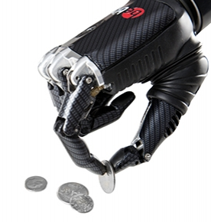

Figure 1: bebionic hand

Next we will discuss hands made by laypeople. These hands were designed and manufactured by people with limited resources. Because of that, the hands are simple and affordable. They set a precedent for inexpensive 3D printed hands. The RoboHand was designed by Richard Van As, a man from South Africa who lost his fingers in an industrial accident. He used a MakerBot 3D printer and created the design on CAD software. The entire assembly is composed of 3D printed parts, with the exception of three components. The hand has a very simplistic design using a system of cables. When the user bends his wrist down, the cables effectively shorten, causing the fingers to curl into a grasping position. When the user bends his wrist up, the hand opens and the fingers release. Although the hand is not medically sanctioned, Richard has used this design to help children suffering from amniotic band syndrome.

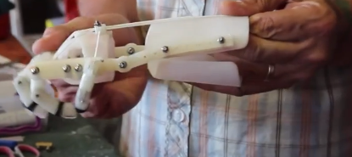

Figure 2: Wrist bent down, fingers grasping.

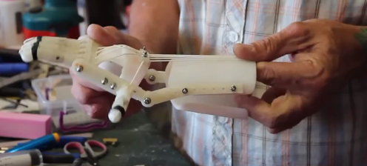

Figure 3: Wrist bent up, grip released.

Another hand that has been created using a 3D printer is called the InMoov. This is a robotic hand not meant as a prosthetic. The hand moves using motors attached to cables on the inside and outside of each finger. When the motor tightens the cables on the inside, the fingers curl in. When the motor releases the inside cables and tightens the cables on the outside, the fingers open. The device is controlled using electrodes attached to the skin that pick up impulses from the muscles, much the like the bebionic3. When the user opens and closes his hand, the robot mimics his actions. Examples of this can be seen in the images below

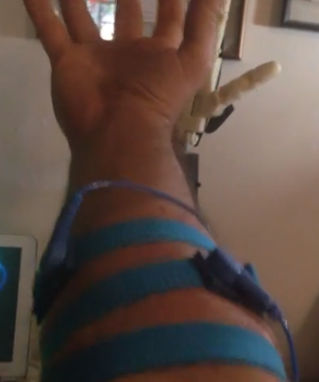

Figure 4: Electrodes attached to the users arm

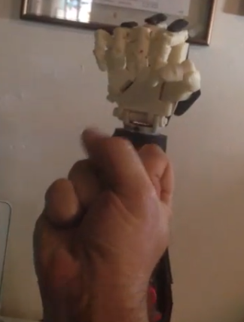 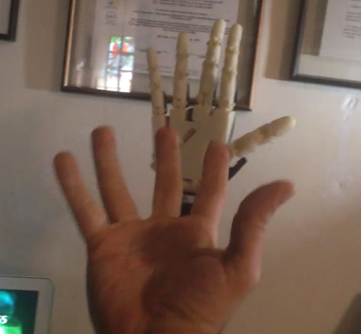

Figure 5: Robot closes fist when user closes fist Figure 6: Robot opens hand when user opens hand

The next topic we will discuss is granular jamming. Research has shown that granules enclosed in a flexible casing are soft and pliable, and can mold around objects. However, when the air is removed, it becomes hard and rigid. Currently this technology is going to be used for robots on assembly lines to help pick up objects, but our team wants to integrate this technology into a robotic hand. A pictorial explanation of granular jamming is provided below.

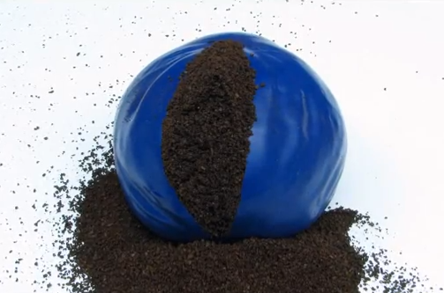 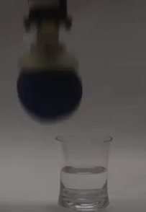

A flexible casing is filled with granules The casing is placed on the end of a robotic arm

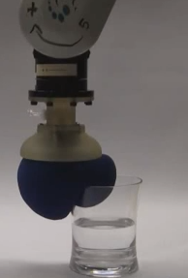 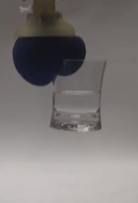

The casing is placed on an Now that the granules are rigid,

object and the air is removed. the robot can pick up the object

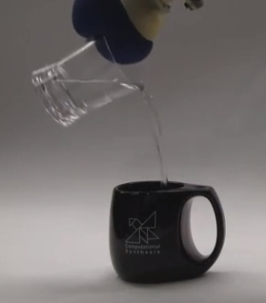 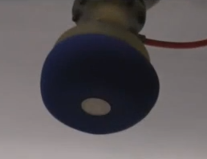

The object is held securely The robot can now do tasks that are difficult for humans, such as picking up a coin off of a flat surface

# Conceptual Designs:

To simplify the design process, conceptual design ideas were split into three categories: hand ideas, which related to the rigid 3-D printed components of the hand; granular jamming ideas, which related to the soft granular jamming pads and accompanying pneumatic assembly; and other considerations, which acted as a catch-all grouping for ideas which were valuable, but did not fit into the other two categories.

In the hand ideas category, methods were considered for the four subcategories: moving joints, holding position, straightening the hand, and sensing grip. For moving joints, pneumatics, motors, and cabling systems were all considered.

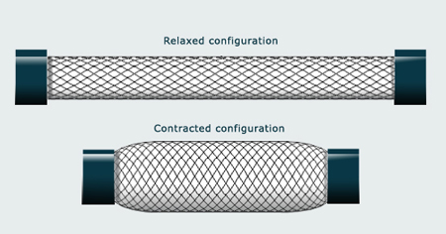

Figure 7: Pneumatic Muscle example.

Filling the muscle with air causes it to contract, getting larger in diameter and decreasing in length. This would be attached to a cabling system which would then pull the fingers inward.

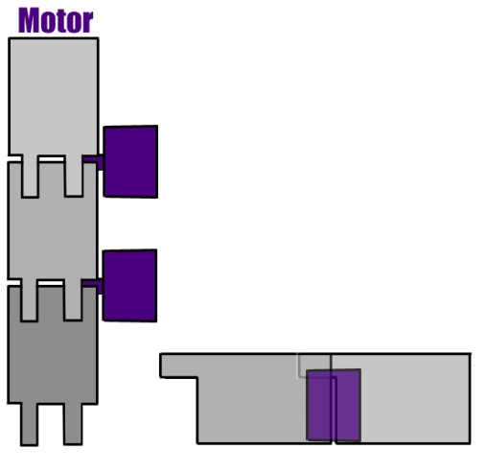

Figure 8: Motor System example. Each joint is run by an individual motor, allowing for a full range of motion.

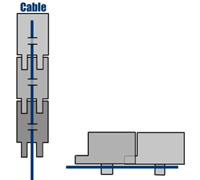

Figure 9: Cabling System example. The cable runs along the underside of the finger, which hinges near the center. Pulling on the cable generates a downward force and pulls the finger inward uniformly to the palm. These cables can be attached to either pneumatic muscles or to motors housed in the forearm.

An additional permutation was also considered, to combine motors at the base of fingers with cables running along their lengths. This would add some dexterity and allow for only the joint at the base of the finger to be moved. To hold joints static, it was considered firstly if it was important enough to warrant spending time and resources designing around static joint options, and secondly, how to do it. The ideas of gear teeth at joint interfaces and external joint locks were both considered. To straighten the hand, the idea of using long elastics, short elastics (at joints only), flat springs, and opposing cables were all explored.

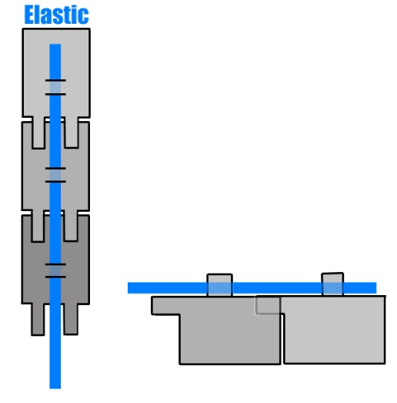

Figure 10: Long elastic example. The elastic runs along the top of the finger, opposing closing motion, and anchors somewhere on the back of the hand. That way when the hand is in a resting state, the fingers will be straight. Teeth on the top of each finger mesh and ensure that the finger will not hyperflex when relaxed, via mechanical interference.

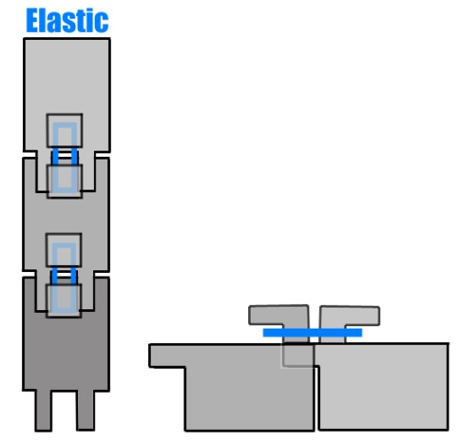

Figure 11: Short elastic example. This elastic is only present at joint interfaces, and is clipped around an outcropping that flares out to ensure that it will not slide off. Teeth on the top of each finger mesh and ensure that the fingers will not hyperflex when relaxed, via mechanical interference.

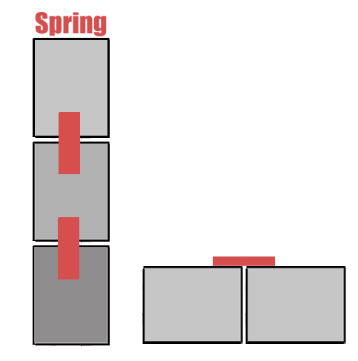

Figure 12: Flat spring example. The flat springs are thin pieces of metal that straighten out when not under force. This ensures that the resting state of the fingers will be straight. Intermeshing teeth are not necessary for this design.

The opposing cable design would simply consist of a set of cables running along the top of the finger (rather than the underside as the closing cables would). Pulling on these cables would pull the fingers upward and therefore straight. Running the two cables against each other would keep the fingers totally rigid. To sense grip, it was considered that there could be no grip sense, and a vacuum activated via button, a bump sensor under the granular jamming pads, and an encoder paired with the servo motors to read if they had reached a stall state.

The second category of conceptual design is granular jamming. This was split into three subcategories: granular jamming material, housing material, and layout of the pads.

For granular jamming material, initially three options were considered: sand, coffee grounds (a material that has been previously shown to work), and plastic stuffing materials, as one would see in a weighted stuffed animal. Housing materials considered included balloons (another material that had been proven to work) and slip-cast silicone (similar to what is used in animatronics and costuming applications).

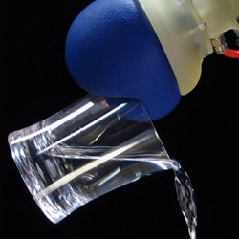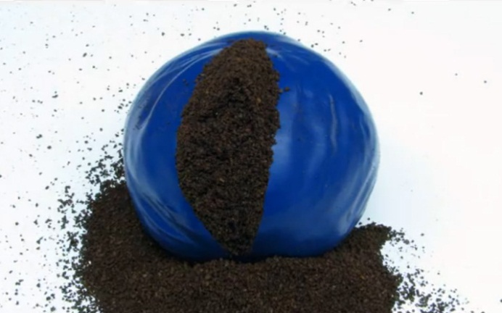

Figure 13: A granular jamming gripper can be as simple as a balloon filled with coffee grounds, as shown here.

For layout, two subcategories were considered. The first subcategory was method of connecting the pads to the vacuum. The group considered whether pads should be interconnected or individually connected via tubing to the vacuum main line. The second subcategory is the layout and location of the pads. Designs for the layout included having pads on each fingertip and the palm, pads on the 3 sections of the finger and the palm, or having pads on two finger sections and the palm.

The third category of conceptual designs was “Other Considerations.” These were good ideas that did not fit into either hand or granular jamming categories. Ideas considered in this category included size, use with touch screens, nails, and printing in polycarbonate plastic. Size was deemed extremely important for the project, as the hand could not be significantly smaller, larger, or heavier than a real human hand. Touch screen usage could be solved with a conductive fabric and was considered a secondary goal, as was the idea of adding prosthetic nails (which are used for certain tasks, such as opening cans).

# Features and Comparisons of Conceptual Designs:

These designs, once generated, were then compared via decision matrices to see which would be the most effective solutions. This would ensure that the best solutions could be selected and that the design could move forward from vague descriptions of how something might work into a stage in which testing and further research could be done.

First to be considered was the joint locomotion. Pneumatic muscles would most accurately mimic the way that a real human arm works, but are also fairly complex, expensive, and possibly difficult to control (since no group members has prior practical experience with pneumatics, learning control methods in addition to doing them may be difficult).

Motors at each joint would have had a full range of motion on each finger joint (to the point that they could easily drive the joint into itself—a distinct disadvantage) but they are also expensive, bulky, and very complex (in order to control the hand it would be necessary to keep track of about 30 different motors).

The cable-and-motor setup would be relatively simple (turn a motor to effectively shorten a cable, drawing a finger in towards the palm), inexpensive (up to five motors would be required to run the fingers—a huge improvement over 30), small, since the cables take up a negligible amount of space and the motors can be housed where there is more space in the forearm, and achieve a fairly accurate range of motion—the only problem being that a human can lock two joints and move just one (such as when typing or playing the piano), and the cables would all move fingers uniformly.

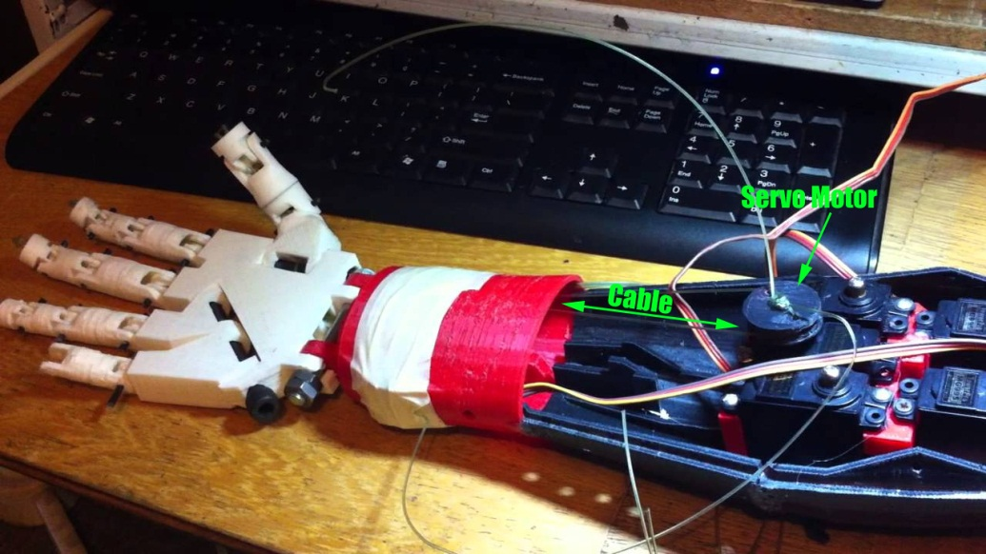

Figure 14: An existing hand design demonstrating the cable-and-motor motion system.

The idea of combining a motor at the base of the finger with cables running along its length was also considered. This base motor could correct the locking-joints problem (by just moving the base of the finger) but the added expense, bulk and complexity (since moving the first joint effectively shortens the cable, so the cable motor would have to run backwards to accommodate the finger base motor whenever base motion was required) which made this solution less than worthwhile. Below is the decision matrix for all of the options considered.

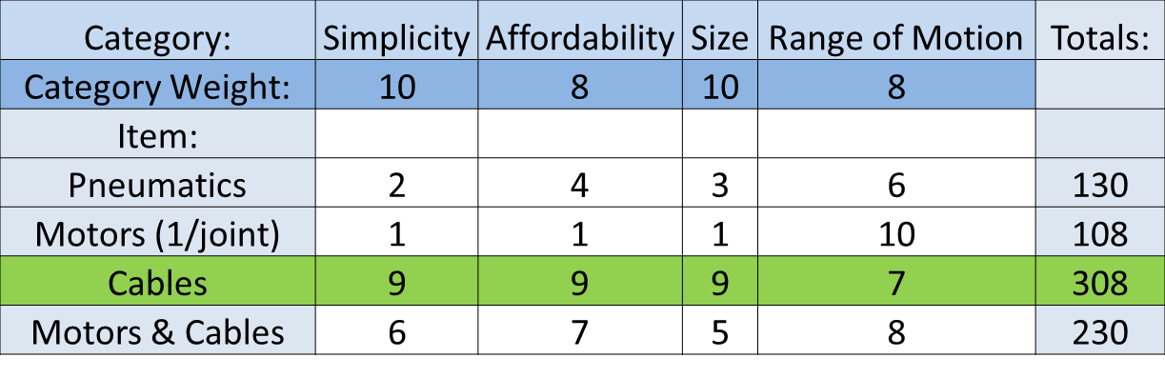

Figure 15: Joint motion decision matrix.

Using a cabling system paired with motors, however, opens up a number of other possibilities: namely the possibility of including one cable for every finger, sharing a cable between the ring and pinky fingers, having one cable per joint in the hand, and having one cable per every two joints in the hand. Having one cable per finger is fairly self-explanatory. Each finger is capable of independent control via a motor in the forearm. Combining the ring and pinky fingers onto one motor would decrease complexity without sacrificing a lot of usability (since the two fingers are actually linked in a human hand). One cable per joint would allow the fingers to “wrap around” objects more efficiently, since the one cable per finger method would just cause the fingers to move uniformly in a C-shape, and 1 cable/2 joints would achieve the same as 1 cable/joint whilst being less complex (and a little less effective). Ultimately however it was concluded that the grip improvement of the granular jamming pads would more than make up for the C-shape of a single-cable finger, and that having five cables was not so much more complex or expensive than having four that it was worth eliminating one. The decision matrix for this design is shown below:

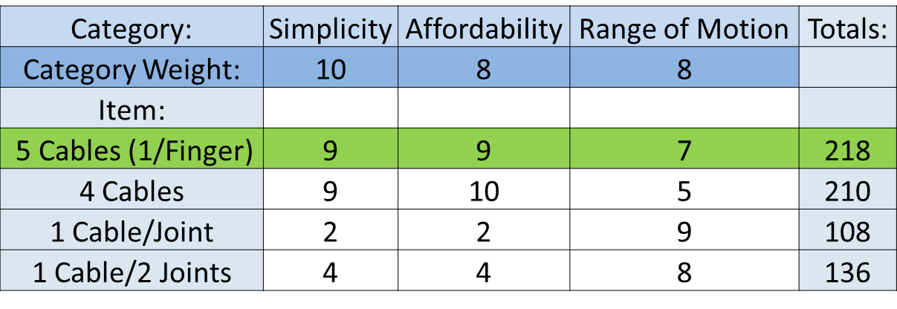

Figure 16: Cabling ideas decision matrix.

Straightening the hand is important because with cabling, it would not have a resting state like a human hand does. Instead it would move around loosely as the arm was moved, making it difficult to position the fingers in useful ways to grip things. As a result, it was decided that the resting state of the fingers should be straight. The four methods considered to straighten the hand were large elastics, small elastics, flat springs, and a second set of cables. The large elastics would do a fine job of keeping the hand straight, but would also incapacitate the entire finger if they snapped, and every time one broke it would be necessary to replace it by threading it back through its housing. Small elastics help to negate this problem by only being at the joints. That way if one snaps, only that joint is incapacitated and they would also be simpler to replace. Flat springs would require less design work, since elastics require plastic outcroppings to keep from hyperextending the fingers all of the time, and would be much more reliable than elastics, but are also harder to repair and more expensive. A second set of cables would allow for hyperflexion when appropriate (and would keep the hand straight when not) but they would also double the number of motors necessary to run the hand, adding significant complexity and cost. The decision matrix for hand straightening ideas is shown below:

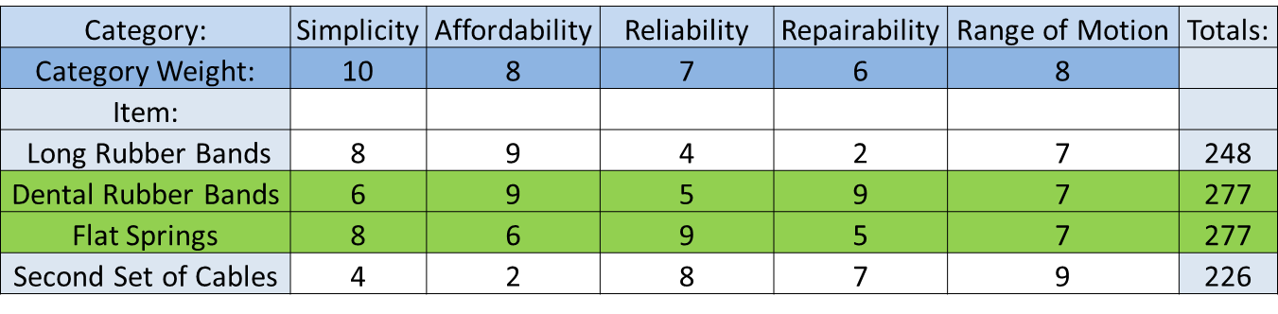

Figure 17: Straightening ideas. Both the dental rubber bands and flat springs proved to be reasonable solutions, so both will be tested (time allowing).

The final consideration for hand mechanics was grip sense. This would sense when the hand has come in contact with an object and can stop closing. The three options considered were user controlled button, bump sensors under the granular jamming pads, and encoders on the servos that could communicate when a motor was stalled, something that occurs when it has collided with an object and cannot move. The user button, while the simplest and most inexpensive solution, was rejected because it assumed the user had use of their other arm. Bump sensors, conversely, were too expensive and complex to be feasible for this project. The number of required sensors would have to be tested, as well as how many would need to be engaged for a proper hold. Being electronic, they would prevent the hand from being waterproof (which, with the cabling system, it will be, since it requires no electronic components in the hand itself—only in the forearm), not to mention the added expense of up to 30 sensors. The encoders were selected as the best choice, since once the finger closed around something, the motor should reach a stall condition. It was also chosen because encoders would likely be necessary to know finger position anyway, so they would not be much of an added expense (and only the same number of encoders as motors would need to be purchased, rather than 30 of them). The grip sense decision matrix can be seen below.

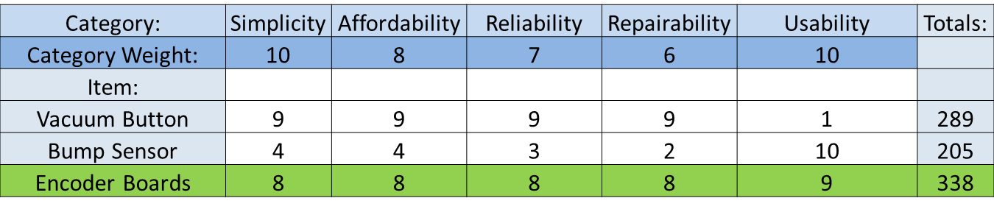

Figure 18: Grip sense decision matrix.

For the granular jamming pads, decision matrices were created on the basis of material, housing, and layout/control of the pads. The first component considered was granular material to be used in the pads. The materials the group considered are sand, coffee grounds, and plastic stuffing materials. All three materials are inexpensive, but each has a drawback. Sand is heavy, coffee grounds will spoil, and plastic stuffing materials are too large for finger tips. The team needs to do more investigation into what material to use.

The next component to consider is the housing material. Materials to consider are balloons and silicone. Balloons are inexpensive, but are not durable or easy to cut into irregular shapes. Silicone is more expensive, but more durable and can be cast into any shape desired.

|  |  |  |  |  |
| --- | --- | --- | --- | --- |
| Category: | Simplicity | Affordability | Feasibility | Totals: |
| Category Weight: | 10 | 8 | 9 |  |
| Item: |  |  |  |  |
| Balloon | 8 | 10 | 7 | 223 |
| Silicone | 9 | 9 | 8 | 234 |

Figure 19: Materials decision matrix.

The final component to consider is the layout of the pads. The pads could either be interconnected or each individually attached to the vacuum. The advantage of having individual attachments is greater control over which pads would be activated during a grip. The downside to this is that it is a control nightmare and makes it very difficult to control properly. The simpler and still effective solution is to have pads interconnected and all jam simultaneously when the vacuum is activated.

Next, the number of pads to be used was considered. Pads could either be on only the fingertip, the tip and the base, or the tip, base, and midsection of the fingers. The higher the number of pads per finger, the higher the ability to grasp and the complexity of the pad control. To help visualize appropriate placement of pads, the group decided to do some preliminary testing. This was done by coating household objects with chalk, grasping the object with a hand, and observing where the chalk stuck to the hand.

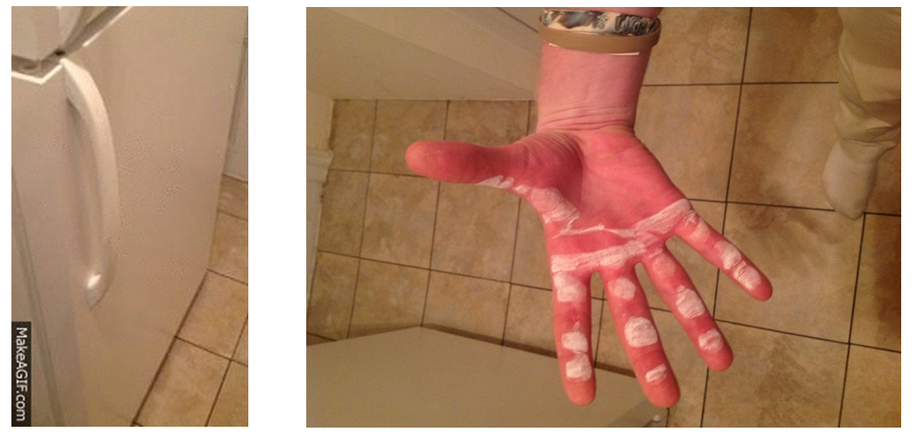

Figure 20: Example of preliminary testing using a refrigerator door handle.

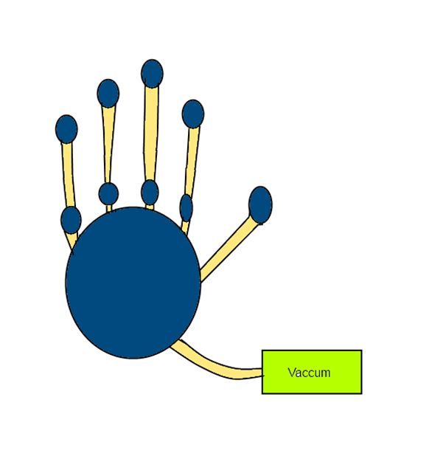The group decided to go with a layout with 2 pads per finger, one at the base, and one at the tip as shown in figure 21, where blue areas are pads of the device, and yellow areas are connection medium. This gave a good balance between functionality and simplicity.

Figure 21: Granular jamming diagram. Blue areas are pads and yellow are connections.

At the first presentation, the panel recommended to reduce the total number of pads to simplify control. The group will take this into consideration and investigate the number of points of contact needed to hold an object and how much force is needed to hold an object in a hand.

# Technical Analysis and Engineering Design:

The most predominant aspect that our project has to focus on is the movement of the right hand. Hands have three degrees of freedom: supination/pronation, extension/flexion and ulnar deviation/radial deviation.

[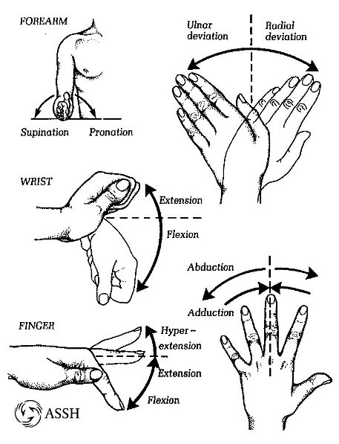](http://www.google.com/url?sa=i&rct=j&q=&esrc=s&frm=1&source=images&cd=&cad=rja&docid=ts9CQ3WJn00fSM&tbnid=-PQKcGkwnI4GOM:&ved=0CAUQjRw&url=http://www.assh.org/Public/HandAnatomy/&ei=9AVAUv_mFvO-4APxsoDoCw&bvm=bv.52434380,d.dmg&psig=AFQjCNER24arUQF3ekTWh0GkXqXRcPqARQ&ust=1380013844177859)

Figure 22: Hand motions.

The granular jamming prosthetic hand will mimic the hand movements that are required to grab an object or twist, for example, a door knob. To do that, the hand will need small motors to generate force, an encoder with sensors to tell when to grab or let go of an object, and the granular jamming system to insure the firmness of the grabbing motion.

[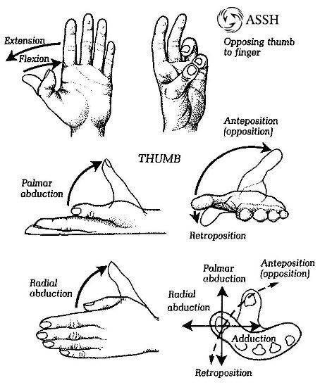](http://www.google.com/url?sa=i&rct=j&q=&esrc=s&frm=1&source=images&cd=&cad=rja&docid=ts9CQ3WJn00fSM&tbnid=7lPJ9ZDU6kJcMM:&ved=0CAUQjRw&url=http://www.assh.org/Public/HandAnatomy/&ei=VQlAUuaBGMWn4APVt4DgBQ&bvm=bv.52434380,d.dmg&psig=AFQjCNGcUe3CYv9HTXhqloem4mL2xRfUug&ust=1380014791067707)

Figure 23: Additional hand motions.

The number of motors required to generate extension/flexion, palmar abduction and twist is to be determined. The prosthetic hand needs at five motors to control five fingers. One motor is needed for every finger, one for solely for twisting motion (if it is included) and possibly a seventh motor for the vacuuming granular jamming system. Thus, the prosthetic hand will require at least five motors, but up to seven. The 3D printable prosthetic hand will not be able to lift very heavy things, but it will be have high functionality. Opening various kinds of door knobs, grabbing an object and controlling the finger tips will be the functions of the prosthetic hand. Since the hand is going to be constructed with 3D printable plastics, we will need to know how much heat and how much pressure it can withstand. The analysis will be done in *Solidworks*.

The granular jamming system in the prosthetic hand needs better fabrication for the outer layer that holds the tiny particles together. The prosthetic hand will need to be used on an everyday basis. Fabrication and reliability are very important. It must be water resistant as well as wear resistant. Thus, we will test with silicone and see how reliable it is.

The hand will have one degree of freedom since we are taking grip motion into consideration. Each cable will control one finger that will have curling motion. The primary objective is to have a curling motion. If the curling motion is complete, then a twisting motion will be added if time allows. In that case, the hand will have two degrees of freedom.

The hand will be built and tested, which is called iterative development. Friction, wear and fabrication of various materials used in making granular jamming will be evaluated.

The governing equations for the hand will be

- Friction Force

- Calculation for time for vacuuming certain volume V given volume flow rate capacity q between atmospheric pressure and inside of granular jamming housing

The exact pressure needed to get all the air out is not determined, but “A Positive Pressure Universal Gripper Based on the Jamming of Granular Material” shows that about 85 kPa is appropriate.

Once our concept is finalized, the team can easily begin to build the model with SCAD or *Solidworks* to study the movements of the prosthetic hand as well as material analysis. Also, the input codes for the encoder will be used to judge finger position. The goal is to test and optimize the duration of activating the motors as well as the vacuum. That way, motion controlling motors, granular jamming systems and sensors will be integrated as we expect.

# Deliverables for End of Semester:

The group came together and set several lofty deliverables for the end of the semester. Throughout the semester technical analysis will be done to keep the project moving forward. The group will continue to do research to gain significant knowledge in the materials, robotics and biomechanical field. This knowledge will help us to both understand and address the impact of the design project in an ethical, environmental, and social context. With hands on experiments, the project designs and interfaces will be tested. Members of the group will become fluent using OpenSCAD to finalize design and complete the prototype for Phases II and III. By the end of the semester the group will also have finalized a bill of materials and created a fully functional website.

# Expected Budget:

|  |  |  |  |
| --- | --- | --- | --- |
| Part | Quantity | Cost | Total |
| dyIO | 1 | 75.00 | $75.00 |
| Polycarbonate 3mm Filament | 1 | 74.99 | $74.99 |
| Natural ABS 3mm Filament | 1 | 37.95 | $37.95 |
| 10 piece rotary encoder set | 1 | 10.00 | $10.00 |
| Servo Motor | 7 | 8.95 | $62.65 |
| 25 1/4th inch stainless steel screws | 1 | 6.49 | $6.49 |
| 30 pack Small Ball Bearings | 1 | 14.95 | $14.95 |
| 30 bag 5/16" rubber bands | 1 | 4.95 | $4.95 |
| VEX Robotics NiMH Robot Battery | 1 | 19.99 | $19.99 |
| 6' Silicone Air Line Tubing | 1 | 3.33 | $3.33 |
| 1 pint Platex Mold Latex | 1 | 36.00 | $36.00 |
| Detailed Plastic Acrylic based | 5 | 2.99 | $14.95 |
| Air Pincette Vacuum Tweezers | 1 | 75.00 | $75.00 |
| Total Price |  |  | $436.25 |

# Project Schedule:

